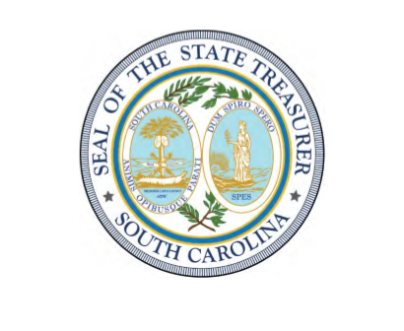
South Carolina
Office of the State Treasurer
Curtis M. Loftis, Jr.
Local Government Debt Report
An Overview and Summary of
Debt Outstanding
As of June 30, 2025

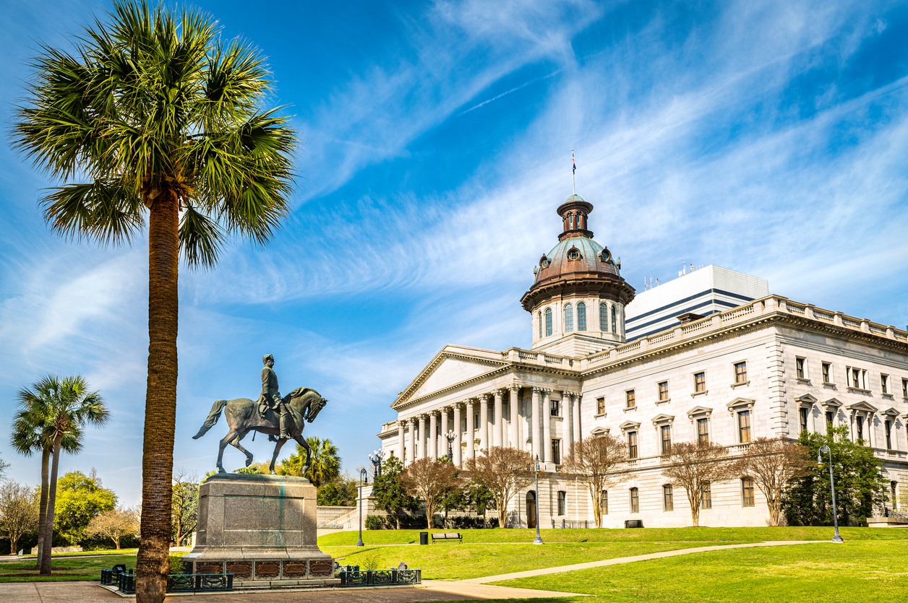

THE HONORABLE CURTIS M. LOFTIS, JR.
State Treasurer

To Governor Henry McMaster, Members of the South Carolina General Assembly, and the Citizens of South Carolina:
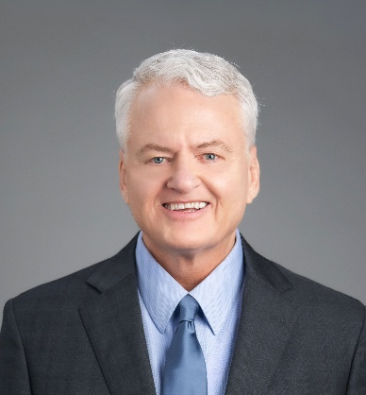
I am pleased to submit this latest edition of the Annual Local Government Debt Report. The information included in this report complies with Section 11-15-100 of the Code of Laws of South Carolina, 1976, as amended, and reflects the debt outstanding of local governments in South Carolina for Fiscal Year Ended June 30, 2025.
The debt information provided in this report has been compiled from local government submissions to the Office of State Treasurer and meets the statutory requirements for reporting annually on the outstanding debt obligations of all local governments. It also serves as a valuable tool to those seeking information for purposes of marketing, purchasing, or selling such debt securities, or for economic development in some of these communities.
This report is part of our ongoing efforts to furnish government officials, taxpayers, and investors with a transparent view of the local governments’ long-term financial obligations.
It is an honor to represent the State of South Carolina as your State Treasurer.
Respectfully yours,
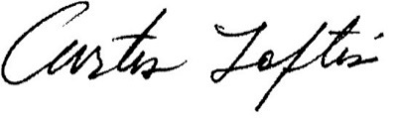
Curtis M. Loftis, Jr.
South Carolina Treasurer

Table of Contents
Summary of County Debt 2
Summary of Municipality Debt 3
Summary of School District Debt 4
Summary of Special Purpose District Debt 5
County Profiles 6
Abbeville 6
Aiken 8
Anderson 12
Bamberg 14
Barnwell 16
Beaufort 18
Berkeley 20
Calhoun 22
Charleston 24
Cherokee 26
Chester 28
Chesterfield 30
Clarendon 32
Colleton 34
Darlington 36
Dillon 38
Dorchester 40
Edgefield 42
Fairfield 44
Florence 46
Georgetown 48
Greenville 50
Greenwood 52
Hampton 54
Horry 56
Jasper 58
Kershaw 60
Lancaster 62
Laurens 64
Lee 66
Lexington 68
Marion 70
Marlboro 72
McCormick 74
Newberry 76
Oconee 78
Orangeburg 80
Pickens 82
Richland 84
Saluda 86
Spartanburg 88
Sumter 91
Union 93
Williamsburg 95
York 97

Summary of County Debt

Summary of Municipality Debt

Summary of School District Debt

Summary of Special Purpose District Debt

County Profiles

Abbeville

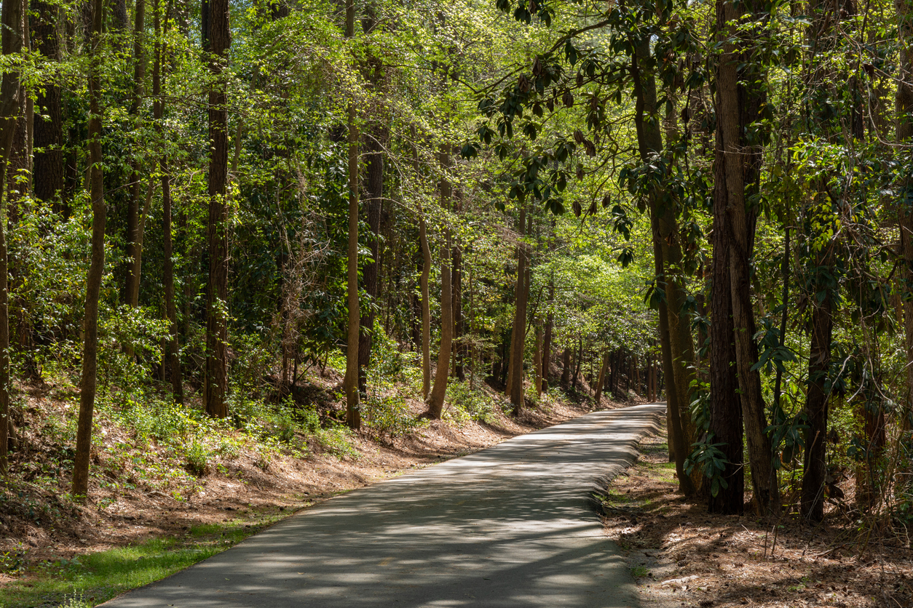

Aiken

Allendale

Anderson

Bamberg

Barnwell

Beaufort

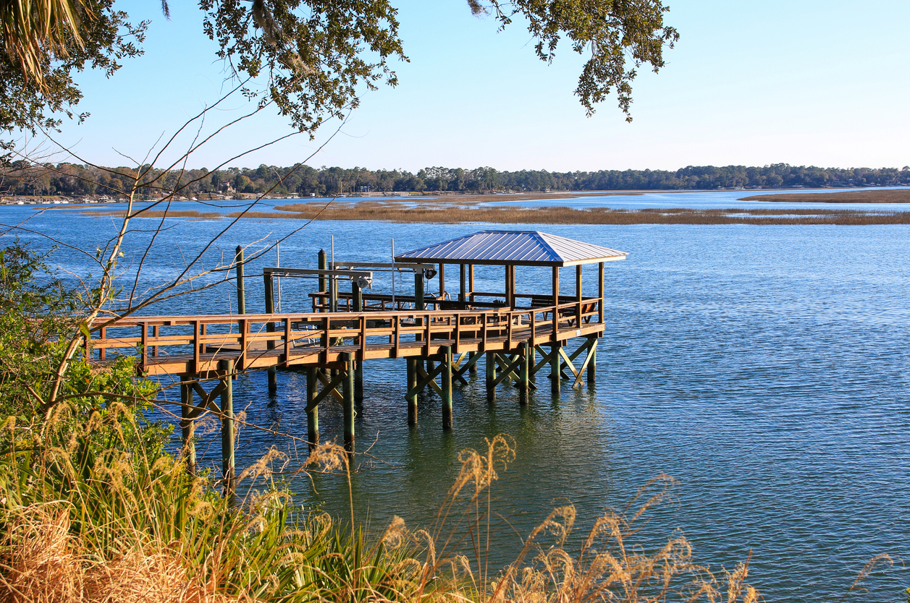

Berkeley

Calhoun

Charleston



Cherokee

Chester

Chesterfield

Clarendon

Colleton

Darlington

Dillon

Dorchester

Edgefield

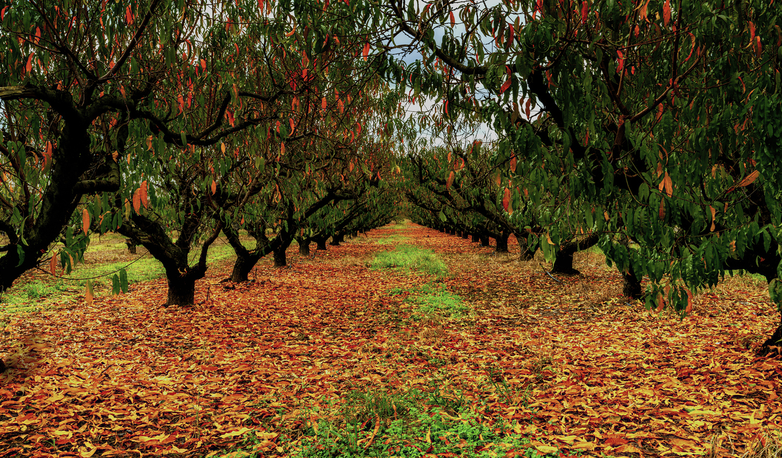

Fairfield

Florence

Georgetown

Greenville

Greenwood

Hampton

Horry



Jasper

Kershaw

Lancaster

Laurens

Lee

Lexington

Marion

Marlboro

McCormick

Newberry

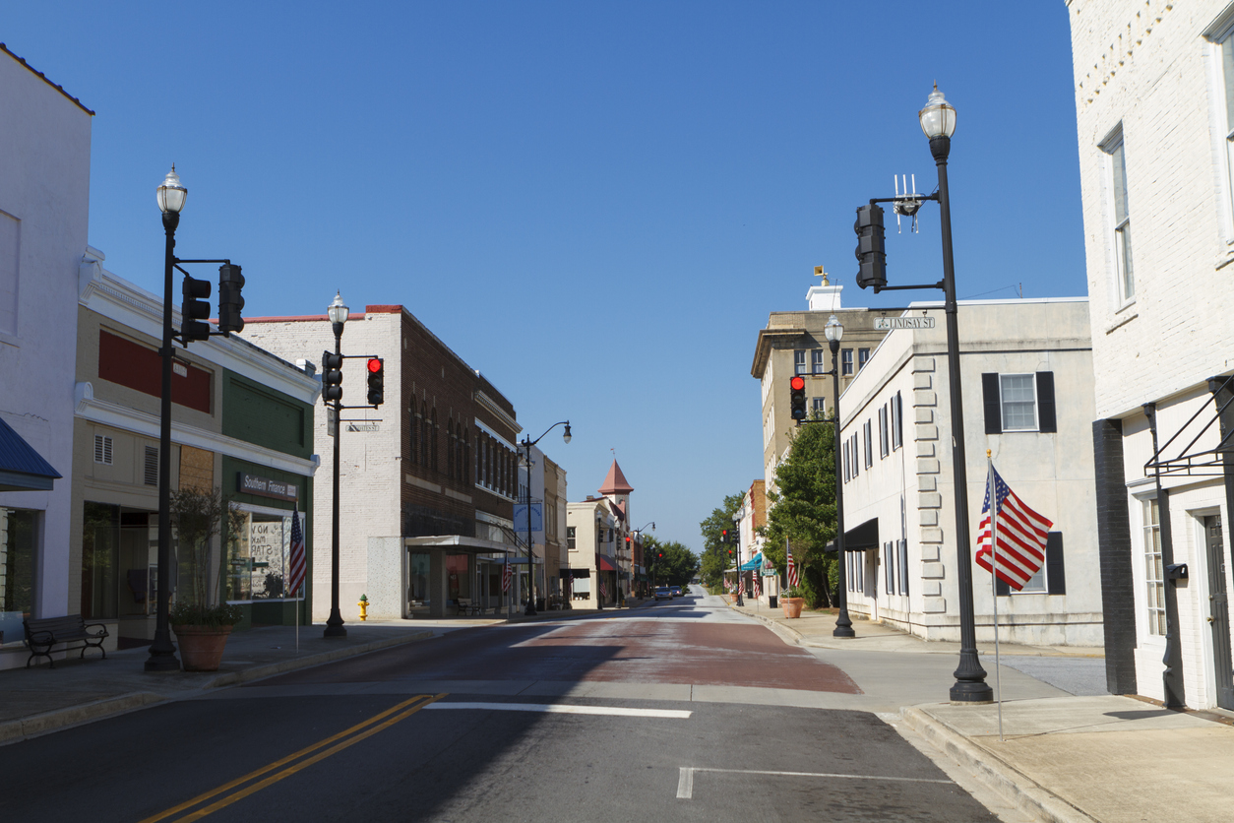

Oconee

Orangeburg

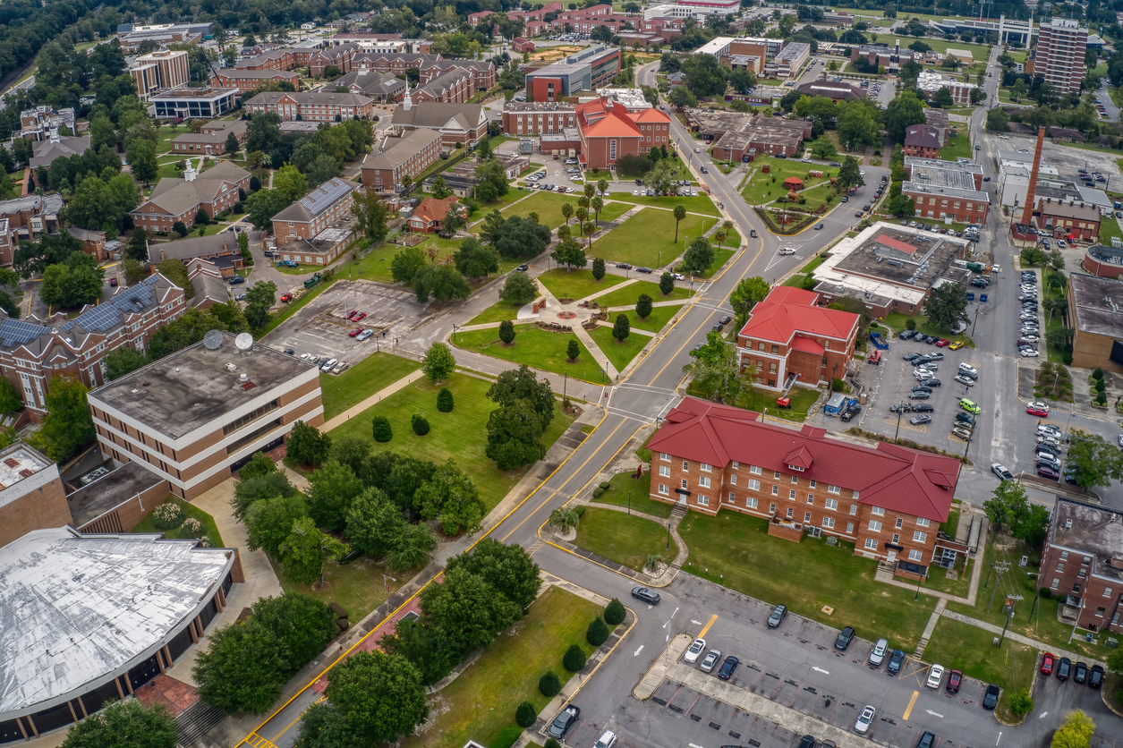

Pickens

Richland

Saluda

Spartanburg

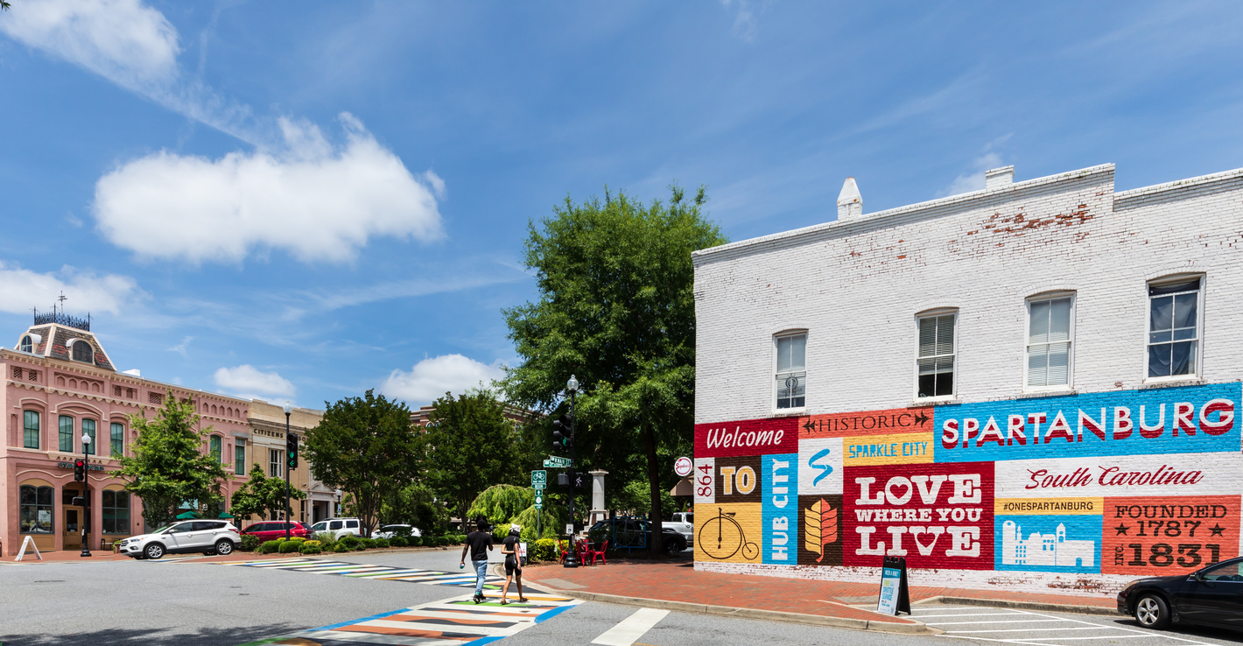

Sumter

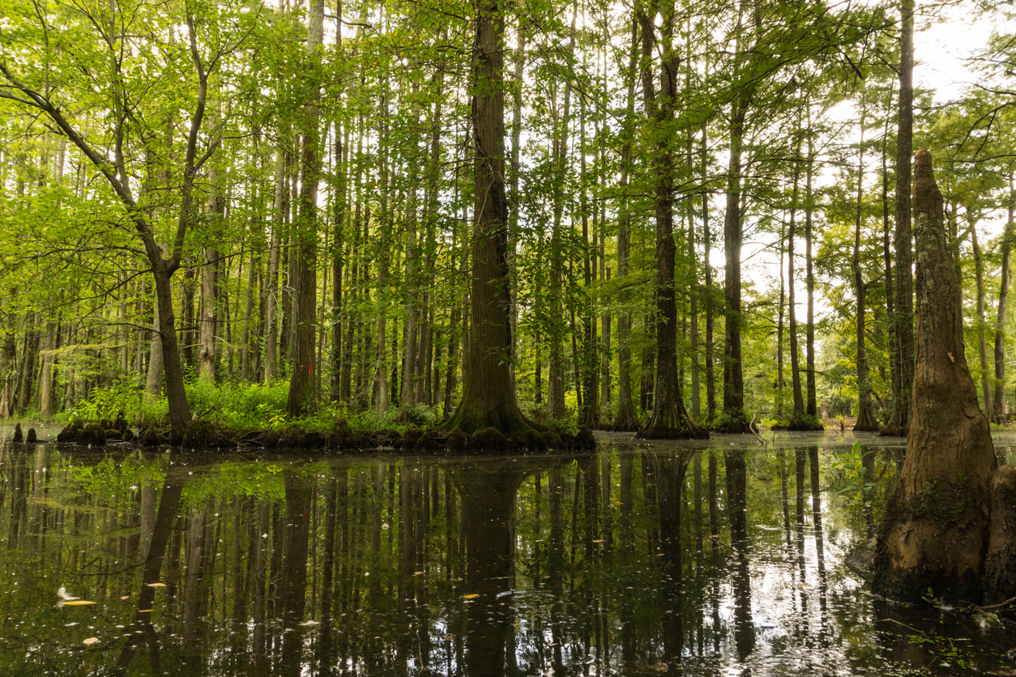

Union

Williamsburg

York

